1. Open ShopPAK  
   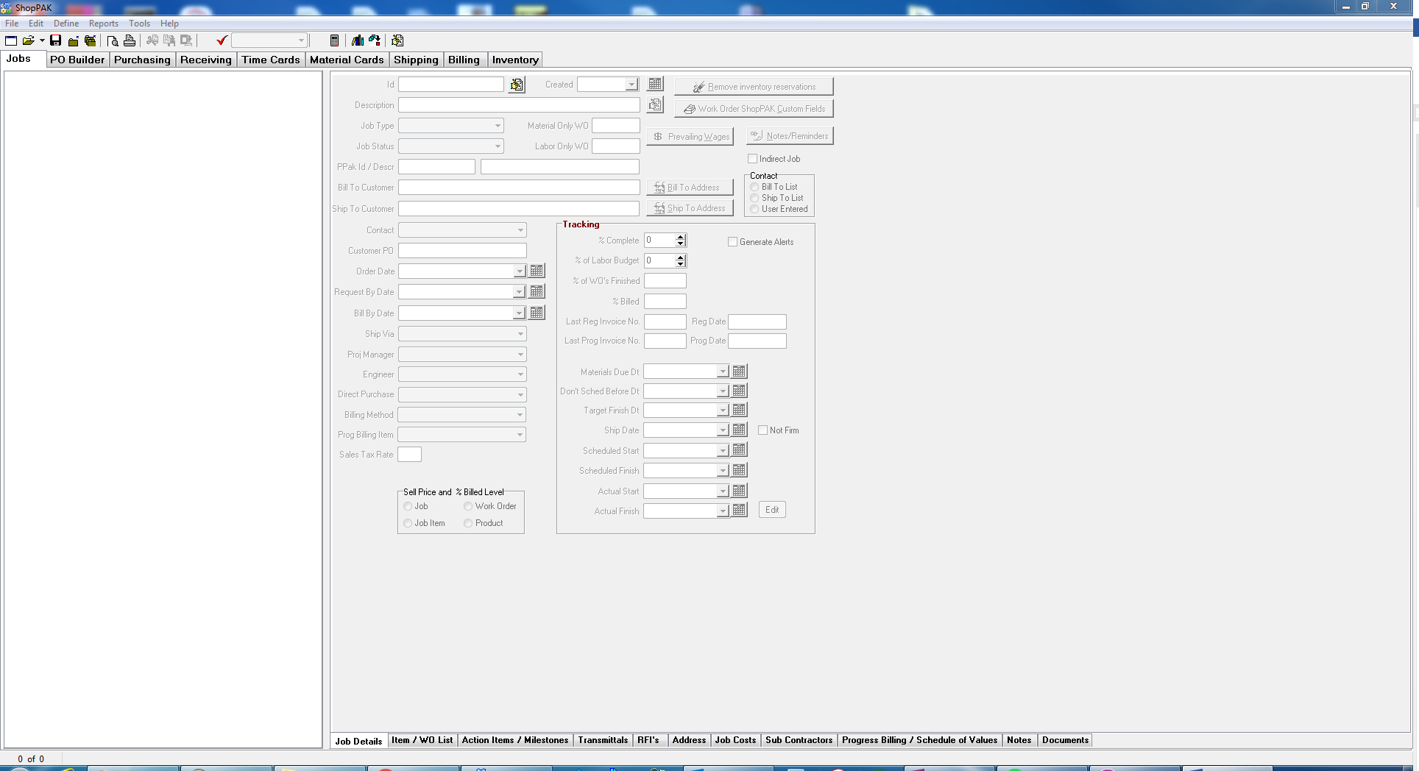
2. Open Job that needs to have Milestone Dates Assigned  
   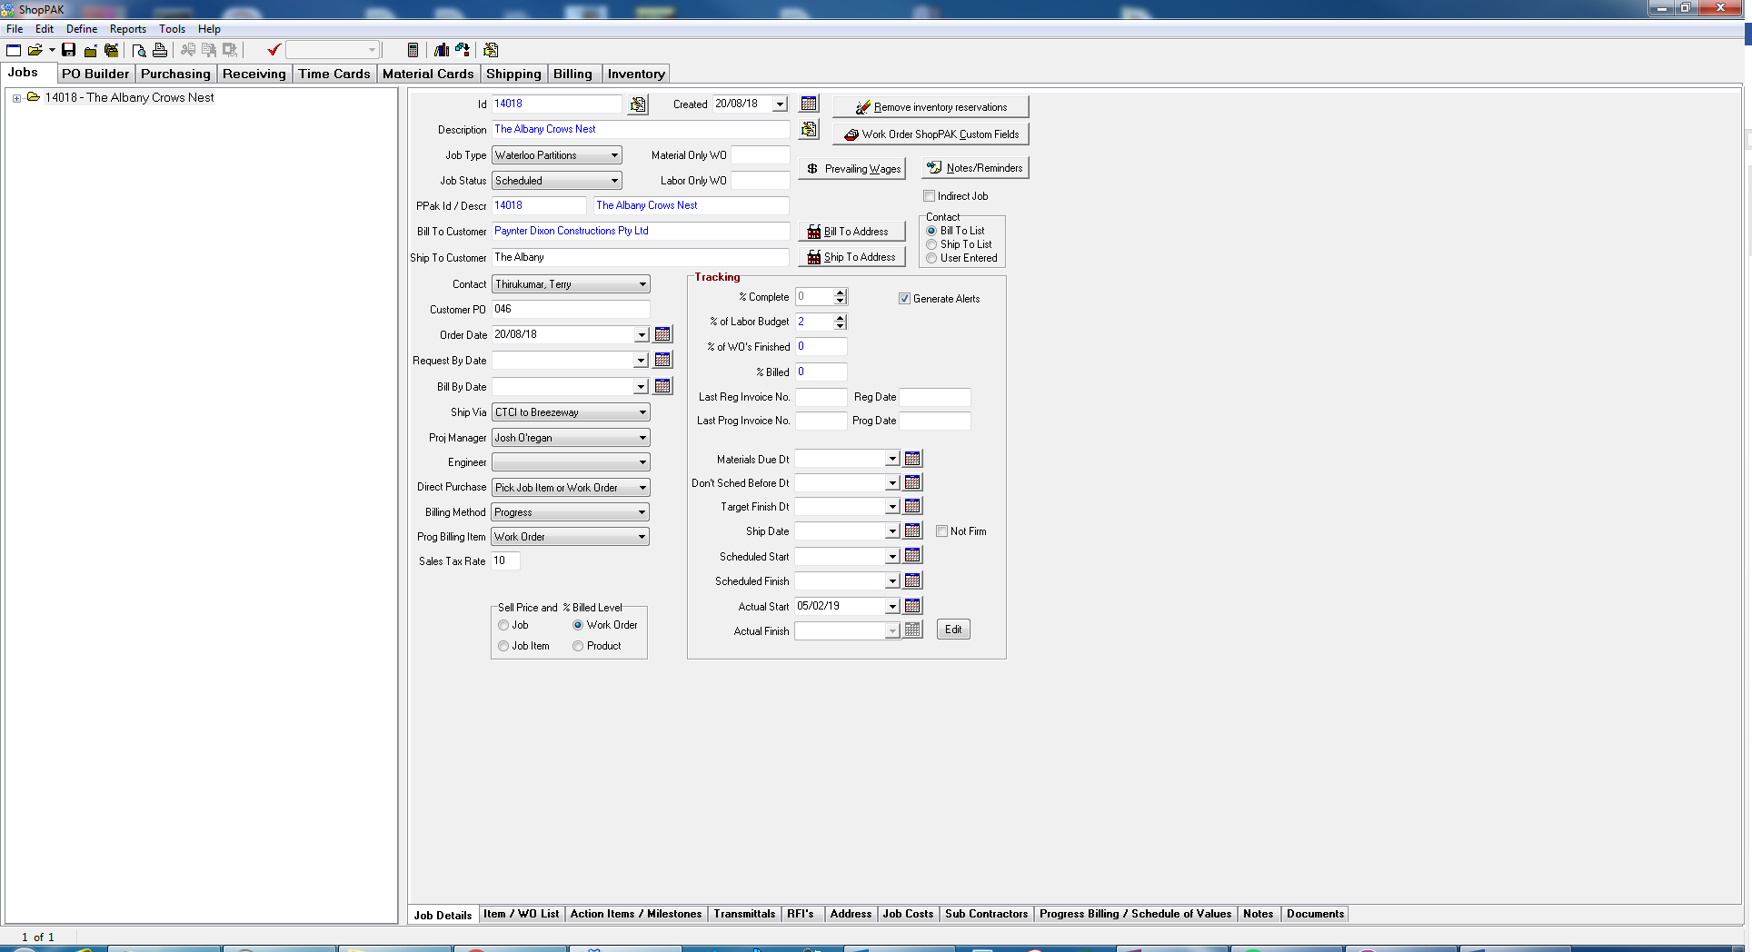
3. Open Action Items / Milestones tab  
   
4. Ensure that the milestones have been selected at the Work Order level.  
   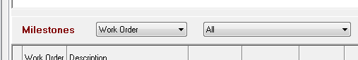
5. In this example we will be setting the date that the cutting list was completed on the first Work Order of this project (10537).  
   Right click on the cell whose completed date you need to set  
   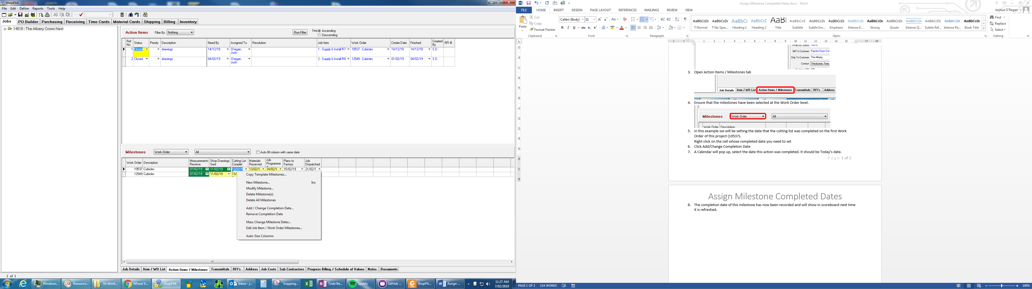
6. Click Add/Change Completion Date  
   
7. A Calendar will pop up, select the date this action was completed. It should be Today’s date.  
   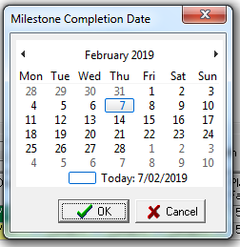
8. Click OK to accept the selected date  
   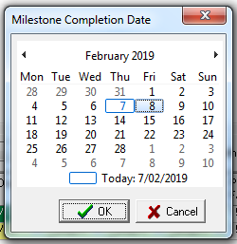
9. The completion date of this milestone has now been recorded and will show in scoreboard next time it is refreshed.  
   